‘oy’
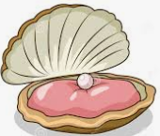
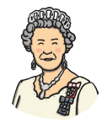
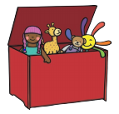
Sound out the word for each picture

______________________ ______________________ __________________________

_________________________ _______________________ _________________________

Choose four words from above and write a sentence for each. Remember a capital letter, finger spaces and full stop.

_____________________________________________________________________________________________________________________________________________________________________________________________________________________________________________________________________________________________________________________________________

