‘w’ and ‘x’

Sound out the word for each picture

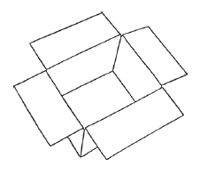

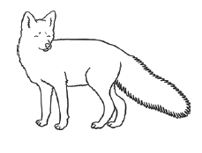

______________________ ______________________ __________________________

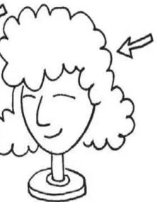

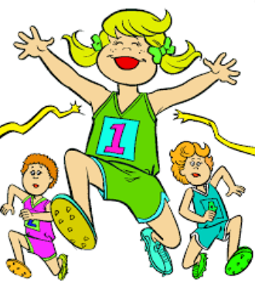

_________________________ __________________________

Choose one word from above and write it in a sentence. Remember a capital letter, finger spaces and full stop.

___________________________________________________________________________________________________________________________________________________________________________________________________