‘zz’ and ‘qu’

Sound out the word for each picture
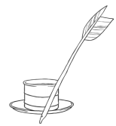
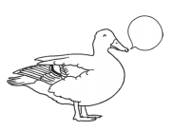

______________________ ______________________ __________________________
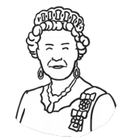
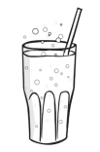

_________________________ __________________________ _________________________

Choose two words from above and write a sentence for each. Remember a capital letter, finger spaces and full stop.

____________________________________________________________________________________________________________________________________________________________________________________________________________________________________________________________________

