‘igh’ and ‘oa’

Sound out the word for each picture
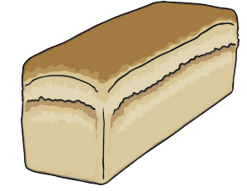
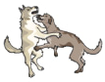

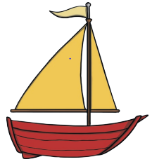
______________________ ______________________ __________________________
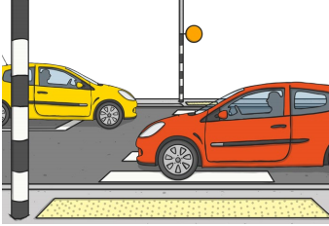

_________________________ _______________________ _________________________

Choose two words from above and write a sentence for each. Remember a capital letter, finger spaces and full stop.

____________________________________________________________________________________________________________________________________________________________________________________________________________________________________________________________________

