‘ear’ and ‘air’

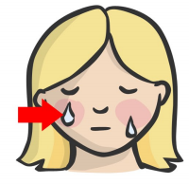
Sound out the word for each picture

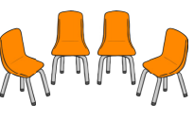

______________________ ______________________ __________________________

_________________________ _______________________ _________________________

Choose three words from above and write a sentence for each. Remember a capital letter, finger spaces and full stop.

____________________________________________________________________________________________________________________________________________________________________________________________________________________________________________________________________

